Because, But, So

# **Teacher Notes**

Make sure the students understand the meaning of each conjunction:

* 'because' to connect a claim with evidence;
* 'but' to introduce a counter-claim;
* 'so' to describe a cause and effect relationship

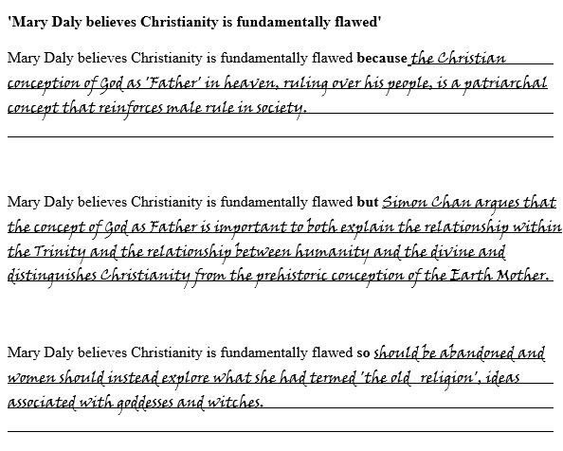Though a simple activity, the rigour comes in the content. This activity is ideal when coming across an exam question for the first time.

Because, But, So

Plato distrusts the senses **because**

Plato distrusts the senses **but**

Plato distrusts the senses **so**

Because, But, So

Descartes believes the mind and body are separate substances **because**

Descartes believes the mind and body are separate substances **but**

Descartes believes the mind and body are separate substances **so**

Because, But, So

Swinburne believes religious experiences points to the existence of God **because**

Swinburne believes religious experiences points to the existence of God **but**

Swinburne believes religious experiences points to the existence of God **so**

Because, But, So

Kant believes an action is good if done for duty’s sake **because**

Kant believes an action is good if done for duty’s sake **but**

Kant believes an action is good if done for duty’s sake **so**

Because, But, So

Bentham believes an action is good if it maximises pleasure **because**

Bentham believes an action is good if it maximises pleasure **but**

Bentham believes an action is good if it maximises pleasure **so**

Because, But, So

Barth believes humans are too flawed to know God through reasoning **because**

Barth believes humans are too flawed to know God through reasoning **but**

Barth believes humans are too flawed to know God through reasoning **so**

Because, But, So

Reza Aslan argues Jesus Christ is a political liberator **because**

Reza Aslan argues Jesus Christ is a political liberator **but**

Reza Aslan argues Jesus Christ is a political liberator **so**

Because, But, So

Mary Daly believes Christianity is fundamentally flawed **because**

Mary Daly believes Christianity is fundamentally flawed **but**

Mary Daly believes Christianity is fundamentally flawed **so**