Oracy Activity Pack for Module 8.5 Prophets

Adapted from activities developed by Voice21

Talking Points (2-3 persons)

Activity

In pairs, discuss the following statements:

‘The rich should do more to help the poor’ (cf. Amos 5.11)

‘People only worship celebrity and money’ (cf. Hosea 2.2)

‘We are destroying our world’ (cf. Jeremiah 4.23)

Remember to use the following sentence stems in your discussion.

|  |  |  |
| --- | --- | --- |
| For building on someone’s ideas… |  | * “I agree and I’d like to add...” * “Linking to your point...” * “Building on that idea...” |
| For challenging someone’s ideas… |  | * “That’s true, but have you considered...” * “You mentioned X but what about...” * “I hear what you’re saying, but...” |
| For summarising the discussion… |  | * “Overall, the main points covered were...” * “In summary...” * “From today’s discussion, it’s clear that...” |

Group Discussion (6 persons)

Activity

Each person in the group must pick up a talking role card:

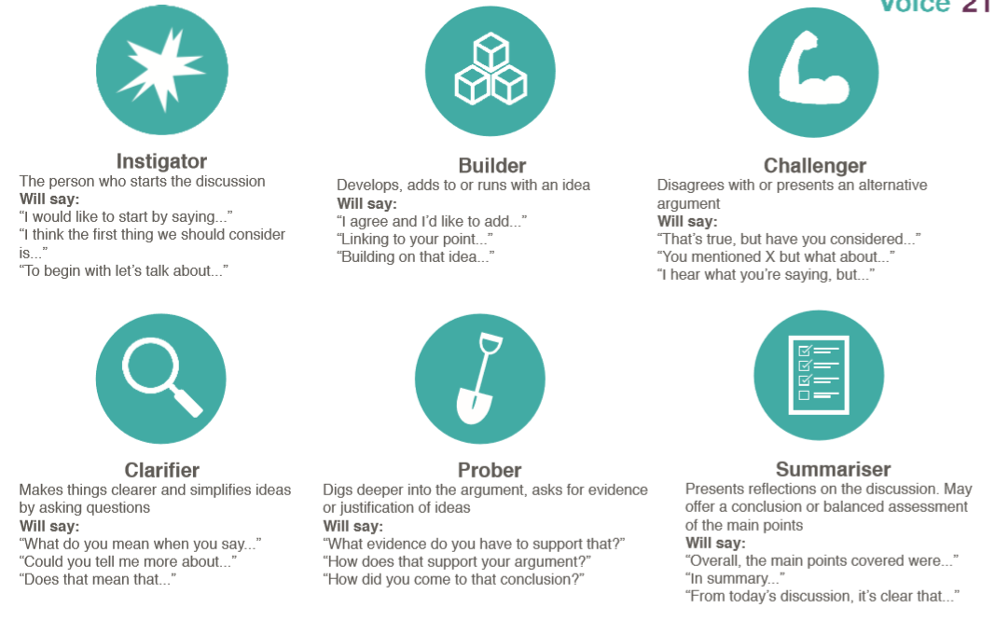

Review the Old Testament prophecies that you stuck in your books last week. In groups you will discuss the following:

‘The Old Testament prophecies are still relevant today.’

1. Instigators have two minutes to present their arguments in favour of the statement, with builders, clarifiers and probers contributing.
2. Challengers then have two minutes to present their arguments against the statement, with builders, clarifiers and probers contributing.
3. At the end of the discussion, summarisers from each group will be asked to share the main points from their group discussion to the rest of the class.

Presentation

Activity

At the end of the topic you will be delivering a presentation on one modern day prophet:

Oscar Romero, Mother Teresa, Jean Vanier, Dorothy Day, Pope Francis

Phase 1: Research

Research your prophet. Where was he or she born? What injustices did they face? How did they respond to that injustice? What is their legacy?

Phase 2: Discussion

Phase 3: Presentation

In the final lesson of this term you will present your findings. After the presentation, you will be assessed by your peers on the following four categories:

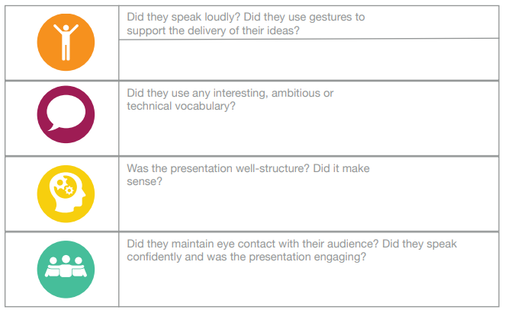

From Speaking to Writing

With more weight given to the evaluation questions in the new GCSE spec (from 40% of the marks to 55%), developing students’ ability to develop, justify and challenge a point of view is even more essential. Talking activities support building these skills, however, some teachers may be worried about not having writing evidenced in the books after such activities. One way around this is for students to write up a summary of the points raised in the discussion activities, both for and against, and answer it as an evaluation question.

Below is an example from a recent class discussion:

Some people may argue that…

‘The Old Testament prophecies are still relevant today.’

because…

|  |  |  |  |
| --- | --- | --- | --- |
|  | **For** | **Against** |  |
|  | Amos warned that the poor were being oppressed. There continues to be great inequality between rich and poor. | Some may argue that the New Testament supersedes the Old Testament, and so they are less relevant. | Use **contrasting connectives** to develop a different perspective...  However,  On the other hand,  In contrast. |
| Use **developing connectives** to support your argument with additional points, such as:  In addition,  Furthermore,  Also | Jeremiah warned that we will be punishment for failing to love God. Christians continue to believe that there will be a Final Judgement. | For those who are atheists, the prophecies are not from God and so not relevant. |
| Isaiah prophesised about the coming of the Messiah. Christians believe the Messiah came through Jesus Christ and await the second coming (Parousia). | Prophecies warning about idolatry, the worship of idols, not relevant. |